**GATEWAY LOAD BALANCER**

it is just deploy,scale and manage a fleet of 3 rd party network virtual appliances in aws.

Example :firewalls.intrusion detection system,deep packet inspection systems,payload manipulation……

You will have a gateway load balancer installed in which all the traffic that comes from the outside will come and will be checked for any threats and if all goes well then it will be sent to our application load balancer.

**EXAMPLE**

Suppose we have a set of users and they want to access our application.They can access our application directly.But we want all that traffic to be inspected first before reaching our application.

So we will have some 3rd party security irtual appliances that will inspect our traffic and if it finds to be non suspected it will send it back to the load balancer and that load balancer will then forwared it to our application..

Gateway load balancer operates at layer 3 or the network layer where the ip packets are inspected.

It combines the following two functions>

:

Transparent network gateway:It acts as a single entry/exit point for all traffic

Load Balancer:It distributes the traffic to the virtual appliances.

An dialso it uses the GENEVE protocol on port 6081.

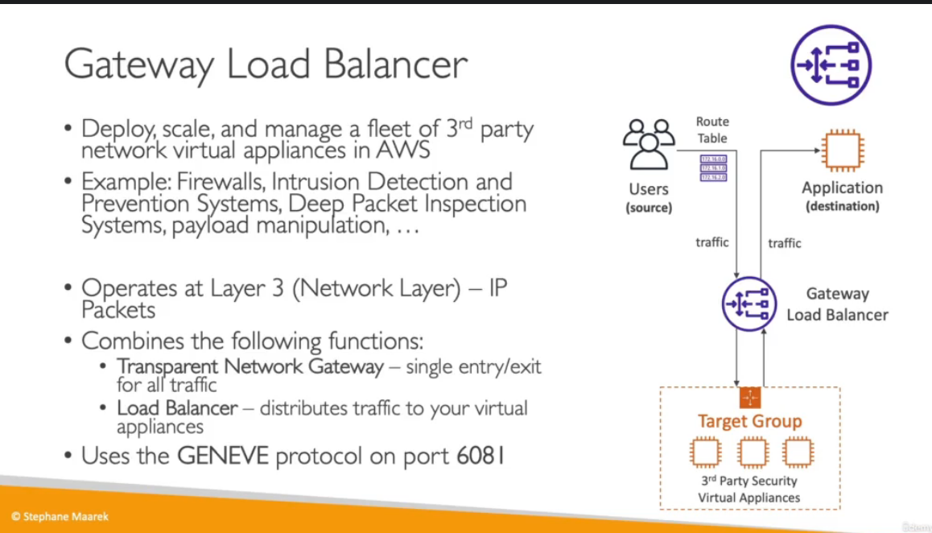

**TARGET GROUPS FOR A LOAD BALANCER**

